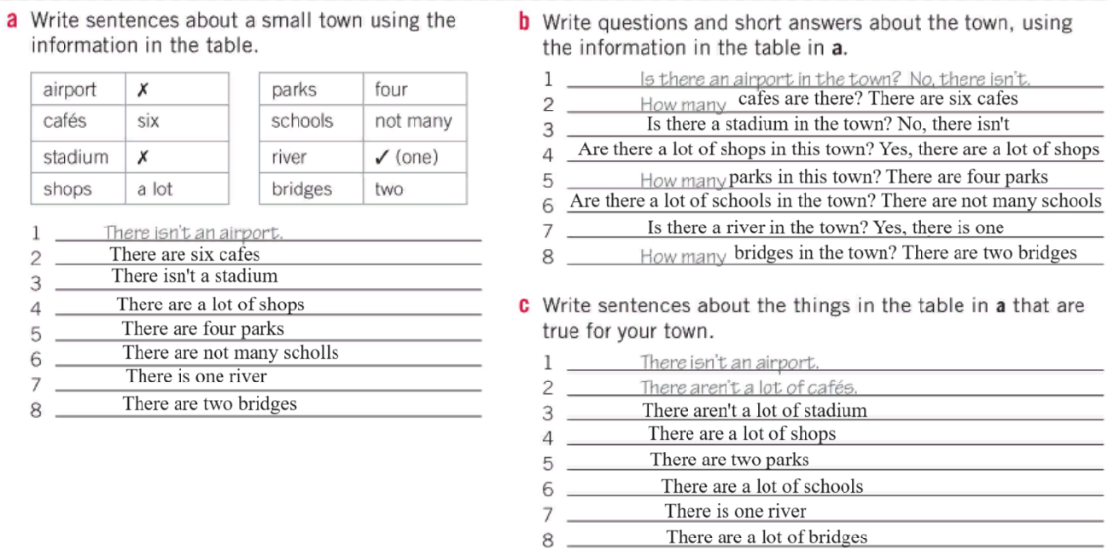

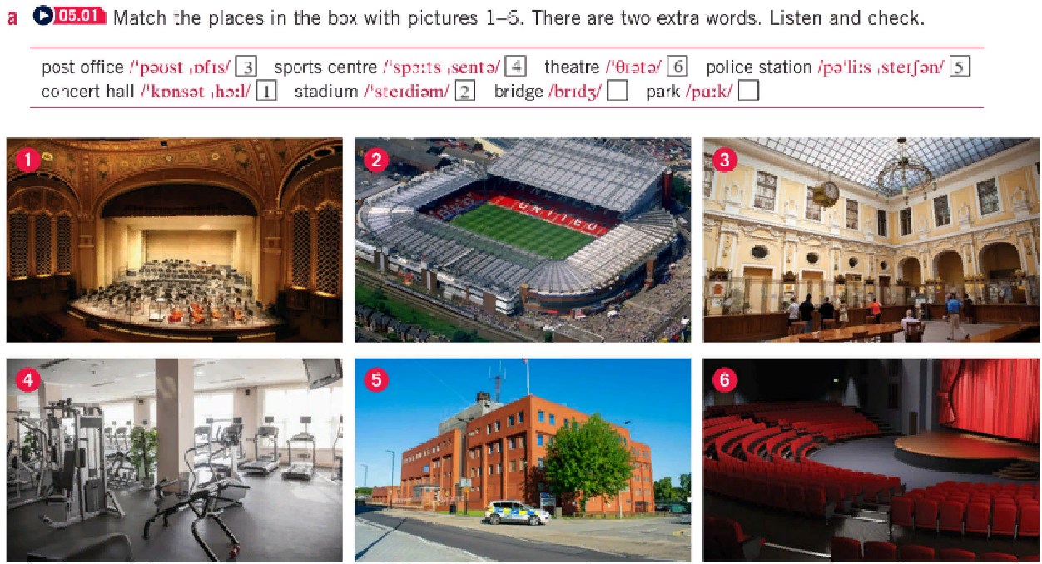

B:

1. stadium
2. park
3. post office
4. bridge
5. stadium
6. police station
7. park
8. concert hall
9. sports center